Haruka Kido

EE456: Digital Image Processing

Assignment 1

1. **Gamma Correction using “forest_gray.png”:**
2. Source Code:

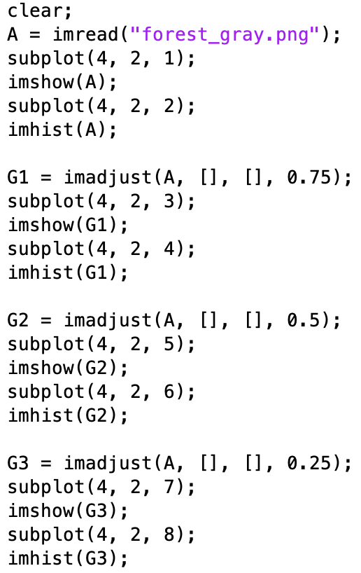

1. Original image and its histogram:

1. 3 contrast-enhanced images and their histograms. Use *imhist* command to plot histograms. Do NOT use built-in MATLAB command for gamma correction:

1. **Histogram and Normalized Histogram of a Gray-Level Image using “pout.tif”:**
2. Source Code:

1. Histogram and normalized histogram. Do NOT use built-in MATLAB command *imhist* for histogram:

1. **Histogram Equalization of Gray-Level Image using “pout.tif”:**
2. Source Code:

1. Original image and its histogram:

1. Chart, histogram

   Description automatically generatedHistogram equalized image and its histogram. Do NOT use built-in MATLAB command *histeq* for histogram equalization: